Buffet Menu
Phone 01189 302444
or e-mail food@la-baguetterie.co.uk to order

We offer a range of buffet services for corporate and private meetings, training days, staff events, picnics, birthday parties, Christenings, and social events. If you do not find what you need below, please call us to discuss your requirements and we will work with you to design a menu.

Selections will be at our choice; however, if you have a particular menu or dietary requirement, we are more than happy to discuss it with you. All menu options are subject to seasonal availability and La Baguetterie reserve the right to make suitable choice substitutions if for operational reasons it becomes necessary.

Freshly squeezed orange juice, carbonated drinks, cartons of juice and crisps are available at additional cost.

Servings in individual personal boxes at £2-00 extra per portion are available.

Local deliveries within a 3-mile radius of the shop will be made free of charge.

We request that all orders are made in writing (email) prior to preparation. Please allow us 48 hours’ notice prior to delivery.

Please return all platters, lids etc. after use.
La Baguetterie reserves the right to charge for unreturned items.

Menu 1 - £4-00 per head + VAT

Platter of freshly filled brown or white mini bread rolls with a range of meat, fish, and vegetarian fillings. NB – this is a “light bite” menu.

-------------------------------ooOoo-----------------------------

Menu 2 - £4-50 per head + VAT

Platter of freshly filled sandwiches with a mixture of brown and white bread and a range of meat, fish, and vegetarian fillings.

-------------------------------ooOoo-----------------------------

Menu 3 - £5-20 per head + VAT

Platter of freshly baked, filled brown and white baguettes and/or wraps with a range of meat, fish, and vegetarian fillings.

-------------------------------ooOoo-----------------------------

For a wider choice, please choose from one of our optional extra items, all prices are per person

Freshly squeezed orange juice £3.00
Carbonated drinks from £1-60 or bottles of water at £1-20
Carton apple or orange juice £0-90p per portion
A packet of Tyrrells potato crisps £1-20
A bowl of assorted crisps at 60p per person
Individual dressed side salad in a pot £2-50

Servings in individual personal boxes at £2-00 extra per portion are available.

Menu 4 - £7-50 per head + VAT

Platter of freshly baked, filled brown and white baguettes, wraps and brown or white sandwiches with a range of meat, fish, and vegetarian fillings.

A selection of assorted cakes and/or mini muffins.

or

A fresh fruit platter or fruit skewers

or a selection of fruit and cake

or

An Optional Savoury Platter – e.g., sausage rolls or pork pies.

For a wider choice, please choose from one of our optional extra items, all prices per person

Freshly squeezed orange juice £3.00
Carbonated drinks from £1-60 or bottles of water at £1-20 Carton apple or orange juice £0-90p per portion
A packet of Tyrrells potato crisps £1-20
A bowl of assorted crisps at 60p per person
Individual dressed side salad in a pot £2-50

Menu 5 – Light Business Lunch
£10-50 per head + VAT (Min 4 people)

2 sandwich triangles or 2 mini wraps filled with a mixture of traditional meat, fish, and vegetarian fillings and
5 choices from the following options: -

Vegetable Crunch
Bite sized canapés’ or crostinis
Mini sausage rolls
Brie and grape skewers
Mini vol-au-vents
Mini pork pies
Mini muffins
Fruit skewers
Fingers of assorted cakes and biscuits

For a wider choice, please choose from one of our optional extra items, all prices per person

Menu 6 - £9-50 per head + VAT
(Min 4 people)

Platter of freshly baked, filled brown and white baguettes, wraps and brown and white sandwiches with a range of meat, fish, and vegetarian fillings.
and

An Asian Savoury Platter with a selection of samosas, onion bhajis and spring rolls
and

Buffet sausage rolls and cocktail sausages and

A selection of assorted small cakes, and/or mini muffins

A Fresh Fruit Platter or Fruit Skewers

or a selection of fruit and cake

For a wider choice, please choose from one of our optional extra items, all prices per person
Freshly squeezed orange juice £3.00
Carbonated drinks from £1-60 or bottles of water at £1-20 Carton apple or orange juice £0-90p per portion
A packet of Tyrrells potato crisps £1-20
A bowl of assorted crisps at 60p per person
Individual dressed side salad in a pot £2-50

Menu 7 - £11-60 per head + VAT
(Min 4 people)

Platter of freshly baked, filled brown or white small baguettes or mini wraps with a range of meat, fish, and vegetarian fillings.

and

Spicy chicken wings or chicken satay and

A collection of savoury canapés or crostinis or vol-au-vents,
Cheese and tomato swirls and

sausage rolls and/or mini pork pies
and

A selection of assorted small cakes and/or mini muffins or
Fresh fruit kebabs or a fresh fruit platter or a selection of fruit and cake

For a wider choice, please choose from one of our optional extra items, all prices per person

Menu 8 – Finger Buffet - £16-50 per head
+ VAT (Minimum 10 people)

Platter of freshly baked, filled brown or white small baguettes, mini wraps and brown or white sandwiches with a range of meat, fish, and vegetarian fillings.
Plus, a choice of 6 items from the following: -
- Brie and grape skewers • Cheese & Tomato Swirls (V) • Quiche:  o Lorraine o Brie & Sunblushed tomato (v)  - Spicy chicken Wings  - Chicken satay w peanut dip | - Filled half croissants  - Canapés  - Tiger prawns with dips  - Savoury tartlets  - Freshly baked brochette (V)  - Crostinis  - Mini vol-au-vents

(V) denotes a vegetarian filling
Platter of assorted cakes and/or mini muffins or

Luxury fresh fruit platter or

Fresh fruit skewers or
a selection of fruit and cake

For a wider choice, please choose from one of our optional extra items, all prices per person

Menu 9 – Fork Buffet - £16-50 per head + VAT
(Minimum 10 people)

- A basket of freshly baked bread with a platter of meats or cheeses  - Brie and grape skewers (V)  - Brochette (V)  - Selection of Mediterranean crudités and dips (V)  - A choice of Quiche from the following: o Lorraine o Brie & Sunblushed tomato (v) | - King prawns with a dip  - Chicken satay with peanut dip  - A choice of 3 salads from the following (V): -  o Rice salad o Potato salad o Waldorf salad o A mixed green salad o Homemade coleslaw o Mixed been salad

(V) denotes a vegetarian filling
Platter of assorted cakes and/or mini muffins or

Fresh fruit platter or

Fresh fruit skewers or
a selection of fruit and cake
For a wider choice, please choose from one of our optional extra items, all prices per person

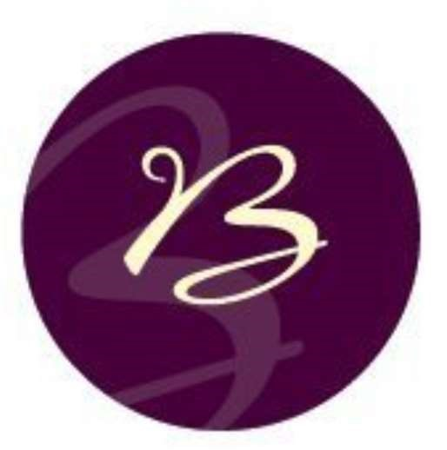
Breakfast Menu

Breakfast Course 1 - Platter of assorted
Viennoiseries and sweet pastries
£2-00 per head + VAT chosen from the following

- Pain au chocolate
- Pain au raisin
- Butter croissants
- Almond croissant
- Chocolate croissant
- Vegan blueberry croissants

-------------------------------ooOoo-----------------------------

Breakfast Course 2 - Freshly baked hot filled brown or white breakfast baguettes and/or croissants
£3-90 per head + VAT chosen from the following: -

- Hot grilled pork sausage
- Hot grilled smoked back bacon
- Hot grilled mushrooms and scrambled free-range eggs. (v)

-------------------------------ooOoo-----------------------------

Please retain all platters, lids etc. for collection or return.

Version 7.1 Page 10 of 13 Print date 02/11/2022
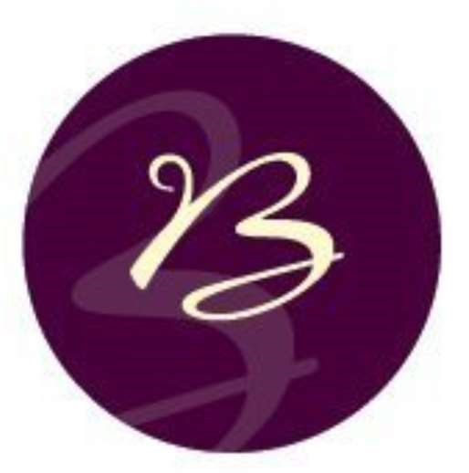
Breakfast Course 3 – Fresh Fruit Platter
(Minimum 6 people)
£4-00 per head + VAT

Breakfast Course 4
Full English Breakfast served in a box
£8-50 per head + VAT

With Sautéed Mushrooms, 2 rashers of Grilled Back Bacon,
2 Choice Pork Sausages, a portion of Heinz Baked Beans,
2 eggs done any way to order and a round of Toast

Refreshing Options per person

Freshly squeezed orange juice £2-80
Carton apple and/or orange juice £0-90p per portion

Breakfast Course 5
Continental Breakfast served on a platter
£12-00 per head + VAT

With a freshly baked butter croissant, a muffin (choice of flavours) or a second pastry,
a selection of ham and salami or smoked salmon, a slice of creamy French Brie or a Cheddar,
a yoghurt and granola pot, fresh strawberries and grapes, jam and butter, two tea bags and a bottle of freshly squeezed orange juice.

Refreshing Options per person

Freshly squeezed orange juice £2-80
Carton apple and/or orange juice £0-90p per portion

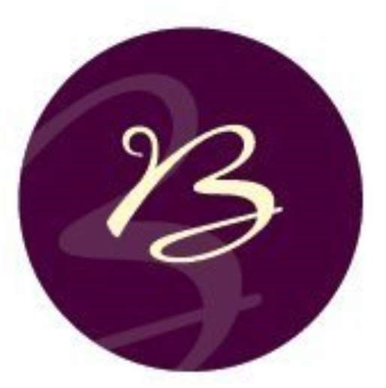
Afternoon and Cream Teas

Full Afternoon Tea £15.00 for one person,
£12-50 per person for two or more + VAT

Including sandwiches, savouries, and cakes followed by fruit scones, clotted cream and strawberry jam
Cheese scones with onion relish or plain scones also available

Afternoon Cream Tea £5-50 for one person
£5-00 per person for two or more + VAT

Including fruit scones, clotted cream, and strawberry jam
Cheese scones with onion relish or plain scones also available

