0 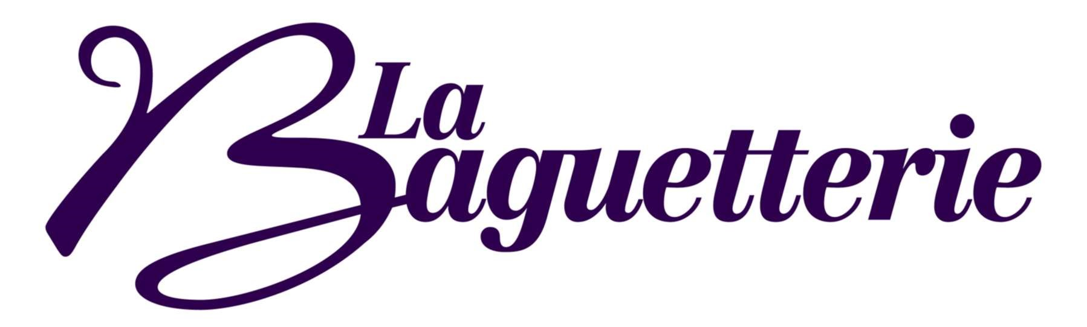
Buffet Menu
Phone 0118334 3488
or e-mail food@la-baguetterie.co.uk to order

We offer a range of buffet services for corporate and private meetings, training days, staff events, picnics, birthday parties, Christenings, and social events. If you do not find what you need below, please call us to discuss your requirements and we will work with you to design a menu.

Selections will be at our choice; however, if you have a particular menu or dietary requirement, we are more than happy to discuss it with you. All menu options are subject to seasonal availability and La Baguetterie reserve the right to make suitable choice substitutions if for operational reasons it becomes necessary.

Carbonated drinks, cartons of juice and crisps are available at additional cost.

Local deliveries within a 3-mile radius of the shop will be made free of charge.

We request that all orders are made in writing (email) prior to preparation. Please allow us 48 hours’ notice prior to delivery.

Please return all platters, lids etc. after use.
La Baguetterie reserves the right to charge for unreturned items.

Menu 2 - £4-50 per head + VAT

Platter of freshly filled sandwiches with a mixture of brown and white bread and a range of meat, fish, and vegetarian fillings.

-------------------------------ooOoo-----------------------------

Menu 3 - £5-20 per head + VAT

Platter of freshly baked, filled brown and white baguettes and/or wraps with a range of meat, fish, and vegetarian fillings.

-------------------------------ooOoo--------------------------

For a wider choice, please choose from one of our optional extra items, all prices are per person

Carbonated drinks from £1-60 or bottles of water at £1-20
Carton apple or orange juice £0-90p per portion
A packet of Tyrrells potato crisps £1-20
A bowl of assorted crisps at 60p per person
Individual dressed side salad in a pot £2-50

Menu 4 - £7-50 per head + VAT

Platter of freshly baked, filled brown and white baguettes, wraps and brown or white sandwiches with a range of meat, fish, and vegetarian fillings.

A selection of assorted cakes and/or mini muffins.

or

A fresh fruit platter

or a selection of fruit and cake

or

An Optional Savoury Platter – e.g., sausage rolls or pork pies.

For a wider choice, please choose from one of our optional extra items, all prices per person

Carbonated drinks from £1-60 or bottles of water at £1-20 Carton apple or orange juice £0-90p per portion
A packet of Tyrrells potato crisps £1-20
A bowl of assorted crisps at 60p per person
Individual dressed side salad in a pot £2-50

Menu 5 – Light Business Lunch
£10-50 per head + VAT (Min 4 people)

2 sandwich triangles or 2 mini wraps filled with a mixture of traditional meat, fish, and vegetarian fillings and
5 choices from the following options: -

Vegetable Crunch
crostinis
Mini sausage rolls
Brie and grape skewers
Mini vol-au-vents
Mini pork pies
Mini muffins
Fruit Platter
Fingers of assorted cakes and biscuits

For a wider choice, please choose from one of our optional extra items, all prices per person

Menu 6 - £9-50 per head + VAT
(Min 4 people)

Platter of freshly baked, filled brown and white baguettes, wraps and brown and white sandwiches with a range of meat, fish, and vegetarian fillings.
and

An Asian Savoury Platter with a selection of samosas, spring rolls
and

Buffet sausage rolls and cocktail sausages and

A selection of assorted small cakes, and/or mini muffins

A Fresh Fruit Platter

or a selection of fruit and cake

For a wider choice, please choose from one of our optional extra items, all prices per person
Carbonated drinks from £1-60 or bottles of water at £1-20 Carton apple or orange juice £0-90p per portion
A packet of Tyrrells potato crisps £1-20
A bowl of assorted crisps at 60p per person
Individual dressed side salad in a pot £2-50

Menu 7 - £11-60 per head + VAT
(Min 4 people)

Platter of freshly baked, filled brown or white small baguettes or mini wraps with a range of meat, fish, and vegetarian fillings.

and

Spicy chicken wings and
a collection of savoury crostinis or vol-au-vents,
Cheese and tomato swirls and

sausage rolls and/or mini pork pies
and

A selection of assorted small cakes and/or mini muffins or
Fresh fruit kebabs or a fresh fruit platter or a selection of fruit and cake

For a wider choice, please choose from one of our optional extra items, all prices per person

Menu 8 – Finger Buffet - £16-50 per head
+ VAT (Minimum 10 people)

Platter of freshly baked, filled brown or white small baguettes, mini wraps and brown or white sandwiches with a range of meat, fish, and vegetarian fillings.
Plus, a choice of 6 items from the following: -
- Brie and grape skewers  - Cheese & Tomato Swirls (v)  - Quiche:  - Spicy chicken Wings | - Tiger prawns with dips  - Freshly baked brochette (V)  - Crostinis  - Mini vol-au-vents

(V) denotes a vegetarian filling
Platter of assorted cakes and/or mini muffins

or a selection of fruit and cake

For a wider choice, please choose from one of our optional extra items, all prices per person

Menu 9 – Fork Buffet - £16-50 per head + VAT
(Minimum 10 people)

- A basket of freshly baked bread with a platter of meats or cheeses  - Brie and grape skewers (V)  - Brochette (V)  - Selection of Mediterranean crudités and dips (V)  Quiche | - King prawns with a dip  - Chicken Wings  - A choice of 3 salads from the following (V): -  o Rice salad o Potato salad o Waldorf salad o A mixed green salad o Homemade coleslaw o Mixed been salad

(V) denotes a vegetarian filling
Platter of assorted cakes and/or mini muffins or

Fresh fruit platter

or a selection of fruit and cake
For a wider choice, please choose from one of our optional extra items, all prices per person

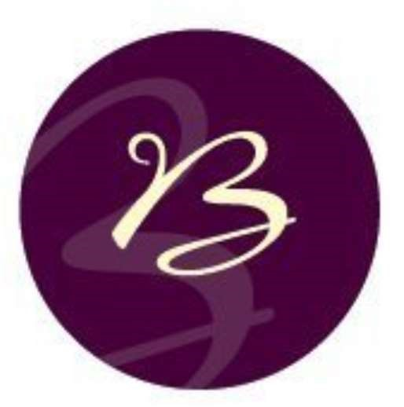
Breakfast Menu

Breakfast Course 1 - Platter of assorted
Viennoiseries and sweet pastries
£2-00 per head + VAT chosen from the following

- Pain au chocolate
- Pain au raisin
- Butter croissants
- Almond croissant
- Chocolate croissant
- Vegan blueberry croissants

-------------------------------ooOoo-----------------------------

Breakfast Course 2 - Freshly baked hot filled brown or white breakfast baguettes and/or croissants
£3-90 per head + VAT chosen from the following: -

- Hot grilled pork sausage
- Hot grilled smoked back bacon
- Hot grilled mushrooms and scrambled free-range eggs. (v)

-------------------------------ooOoo-----------------------------
Please retain all platters, lids etc. for collection or return.

Version 7.1 Page 10 of 13 Print date 02/11/2022
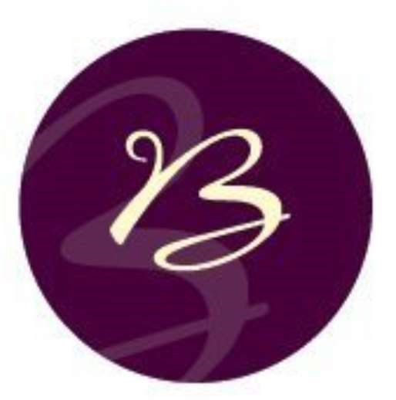
Breakfast Course 3 – Fresh Fruit Platter
(Minimum 6 people)
£4-00 per head + VAT

Breakfast Course 4
Full English Breakfast served in a box
£8-50 per head + VAT

With Sautéed Mushrooms, 2 rashers of Grilled Back Bacon,
2 Choice Pork Sausages, a portion of Heinz Baked Beans,
2 eggs done any way to order and a round of Toast

Refreshing Options per person

Carton apple and/or orange juice £0-90p per portion

